Latest Firmware version issued on 21st, May, 2020, please check carefully before updating, please check the modifications in blue color

Following two are for the version of 10.000 contacts only
MD-9600(GPS-REC)-S26.45.bin for GPS version
MD-9600(REC)-D26.45.bin for common version

Following two are for the version of 100.000 contacts
MD-9600(CSV-GPS)-P26.45.bin for GPS version
MD-9600(CSV)-V26.45.bin for common version

21-5-25
Solve the issue that when you change the zone, and power off, then on again, display will show unprogrammed

Hardware: change PLL IC, and this modifications make firmware version cannot be compatible with previous one, so please check serial number, which is from 2006T00881 and 2006U01000 and the serial number from 2006U00001 and serial number from 2010A00001 all use new PLL, and from 26, May, we will put on one label of 2571 to tell the difference, if your radio has one label 2571, please use the firmware starts from 26

Software: Address the issue that some radio will ask for password after update

Programming software: V1.27
Before using this new programming software, please use the model software named as TYT9600 factory V2.018 to set the model first, please read from this software first, and choose 144-146/430-440MHz, then write into radio, this is only for EU customers
And some ham will find the radio have only one band after upgrading, so please write also with this factory, please write above one UHF and below one VHF
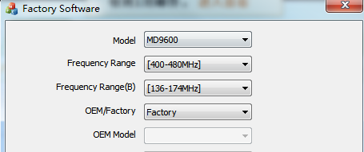
And some users also found that the radio will show enter password even you didnt set the password after upgrading, please set password=0 in the programming software into password=password
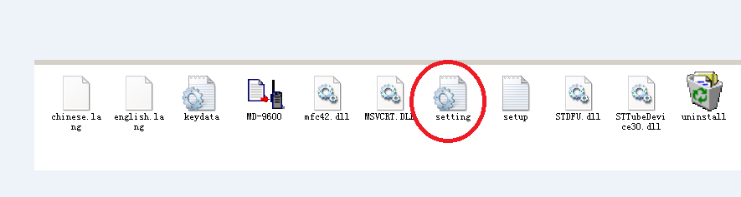
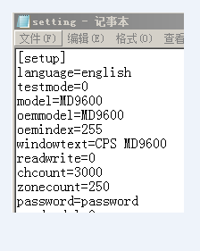
Press P1 and Emergency key to connect the power supply
user programming

